Clint McCoss Kindness Scholarship
Clint McCoss Kindness Scholarship



Awards Reception
Thursday, May 22, 2014
8:00 P.M.

Welcome & Introductions
Tim Alcorn & Megan Weber

Scholarship Mission
Cori Ann Dahlager

Infinitely Yours
Tanya McCoss-Yerigan

Recipient Characteristics
Sam Isfeld

2014 Awards Presentation
Garrett McCoss & Ethan Weber
Anton Leiseth & Kevin Weber

- Allison Carmany
- Logan DeBlieck
- Morgan Field
- Mason Frerichs
- Cody Mathiowetz
- Keysha Panitzke
- Samantha Rigge
- Isaac Rillo
- Paige Ryer
- Morgan Svobodny
- Austin Vikander
- Allie Zieske

Thank You
Tammy McCosh
~ ~ ~ ~ ~ ~ ~ ~ ~ ~ ~ ~ ~ ~
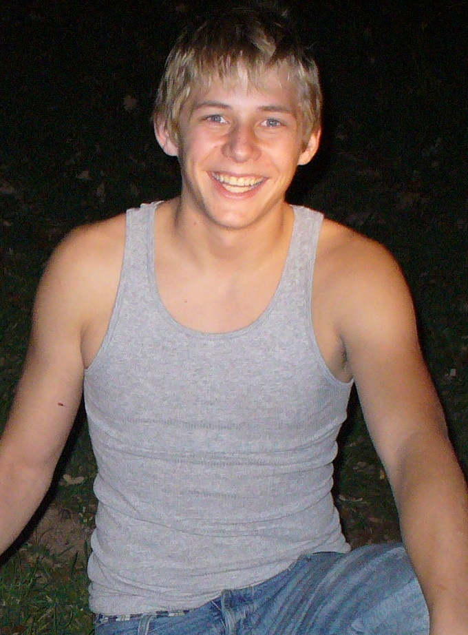

“I live life to the fullest so when it’s my time to go,
it’ll be a great day!”
~Clint~
July, 2006
~ ~ ~ ~ ~ ~ ~ ~ ~ ~ ~ ~ ~ ~
Scholarship Committee

Leroy & Brenda Ohlson Paul Hoernemann
Chris Kleven Tim Alcorn
Kevin Weber Sam Isfeld
Diane Weber Ethan Weber
Anton Leiseth Megan McCoss Weber
Garrett McCoss Briana Yerigan
Cori Ann Dahlager Tammy McCosh

Clint McCoss Kindness Scholarship

Awards Reception
Thursday, May 22, 2014
8:00 P.M.

Welcome & Introductions
Tim Alcorn & Megan Weber

Scholarship Mission
Cori Ann Dahlager

Infinitely Yours
Tanya McCoss-Yerigan

Recipient Characteristics
Sam Isfeld

2014 Awards Presentation
Garrett McCoss & Ethan Weber
Anton Leiseth & Kevin Weber

- Allison Carmany
- Logan DeBlieck
- Morgan Field
- Mason Frerichs
- Cody Mathiowetz
- Keysha Panitzke
- Samantha Rigge
- Isaac Rillo
- Paige Ryer
- Morgan Svobodny
- Austin Vikander
- Allie Zieske

Thank You
Tammy McCosh
~ ~ ~ ~ ~ ~ ~ ~ ~ ~ ~ ~ ~ ~

“I live life to the fullest so when it’s my time to go,
it’ll be a great day!”
~Clint~
July, 2006
~ ~ ~ ~ ~ ~ ~ ~ ~ ~ ~ ~ ~ ~
Scholarship Committee

Leroy & Brenda Ohlson Paul Hoernemann
Chris Kleven Tim Alcorn
Kevin Weber Sam Isfeld
Diane Weber Ethan Weber
Anton Leiseth Megan McCoss Weber
Garrett McCoss Briana Yerigan
Cori Ann Dahlager Tammy McCosh


Awards Reception
Sunday, May 23, 2010
3:00 P.M.

Opening Prayer

Welcome

Clint’s Scholarship Mission

2010 Awards Presentation

- Dustin Baker
- Katrina Frank
- Logan Johnson
- Tara Roden
- Cynthia Trevino
- Jordan Hagert

Thank You

Closing Prayer

Refreshments
~ ~ ~ ~ ~ ~ ~ ~ ~ ~ ~ ~ ~ ~
“I live life to the fullest
so when it’s my time to go,
it’ll be a great day!”
~Clint~
July, 2006
~ ~ ~ ~ ~ ~ ~ ~ ~ ~ ~ ~ ~ ~

Scholarship Committee

Leroy & Brenda Ohlson Paul Hoernemann
Loddie Krepps Chris Kleven
Tammy McCosh Tom Volstad
Kevin Weber Hollis Weber
Jackie Meyer Pam Weber
Bobbie O’Brien Megan McCoss
Garrett McCoss Briana Yerigan
Tim Yerigan Tanya McCoss-Yerigan

